1. Press the Preview button at the bottom of page and then press green button Generate.

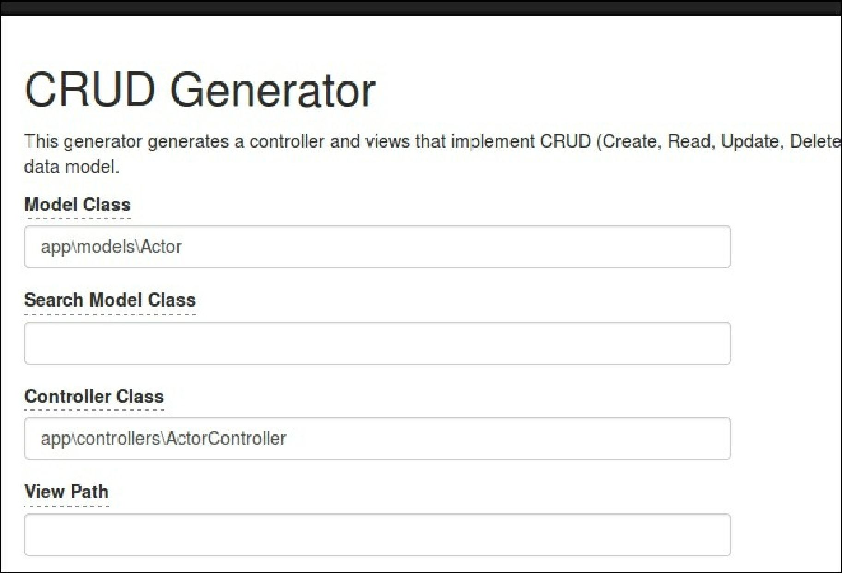

1. Check the result via http://localhost:8080/index.php?actor/create.